**Project Design Phase-II**

**Data Flow Diagram & User Stories**

|  |  |
| --- | --- |
| Date | 18 may 2023 |
| Team ID | NM2023TMID21333 |
| Project Name | Project - Crime Vision: Advanced Crime Classification with Deep  Learning |

# Data Flow Diagrams:

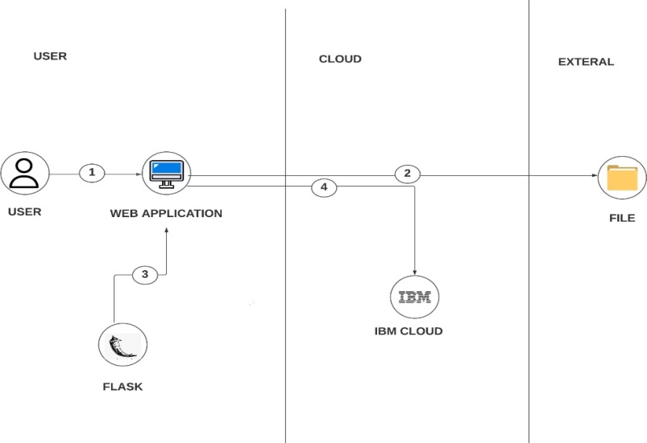

**Description:**

1. User configures credentials for the web application and starts app.
2. User selects the data file (image to classify crime).
3. Files are being used to predict by the application.
4. Predicted class of crime is displayed in the web page.

**User Stories:**

|  |  |  |  |  |  |  |
| --- | --- | --- | --- | --- | --- | --- |
| **User Type** | **Functional Requirement (Epic)** | **User Story Number** | **User Story / Task** | **Acceptance criteria** | **Priority** | **Team Member** |
| Customer (Mobile user) | Registration | USN-1 | As a user, I can register for the application by  Entering my email, password, and confirming my password. | I can access my account / dashboard | High | Dharmesh |
|  |  | USN-2 | As a user, I will receive confirmation email once I have registered for the application. | I can receive confirmation email & click confirm | High | Hemanth |
|  | Login | USN-3 | As a user, I can log into the application by entering email & password |  | High | Naresh |
| Customer (Web user) | Prediction | USN-4 | As a user, I can use the application to classify the type of crime in the data. |  | High | Hemanth |
| Customer Care Executive | Help users | USN-5 | As a customer care executive, I should reply to users doubts and contact administrator in case of any complaints provided by the  Customers. |  | High | Divya |
| Administrator | Maintaining | USN-6 | As an administrator, I will make sure the application is free from malware attacks and try to enhance the features of the application and provide updates accordingly. |  | High | Dharmesh |